SMART CITY

DATA ANALYTICS SOFTWARE SOLUTIONS FOR SMART CITIES



**Prepared by :**

* **Amina Ahmed Mohamed Abounawara (4)**
* **Dina Abdallah Said Ahmed (5)**
* **Habiba Khaled Mohammed Mahmoud (6)**

**Presented For : - Dr.Mohamed Mounir**

30.04.2019

2nd GRADE COMPUTER SCIENCE

STATISTICAL ANALYSIS COURSE

# INTRODUCTION

Smart cities are challenging current big-data analytics software solutions. Smart cities require to process on the fly and at rest, huge amounts of heterogeneous data coming from geographically dispersed sources. And Many governments are considering adopting the smart city concept in their cities and implementing big data applications that support smart city components to reach the required level of sustainability and improve the living standards. Smart cities utilize multiple technologies to improve the performance of City Planning , transportation, energy,education services leading to higher levels of comfort of their citizens.

One of the recent technologies that has a huge potential to enhance smart city services is big data analytics. And the Goals of the project is shown below.

# Goals :

1. Use statistical analysis to analyze large data and clarify the problems and advantages of all the fields situation in one specific country.
2. It discusses and compares different definitions of the smart city using large data and explores the opportunities, challenges and benefits of incorporating data applications for smart city and solution for some challenges.

# Project Description :

In Smart City App. represented Data Visualization in 40+ Charts of UK Smart City by different Forms Of graph.The charts are grouped based on the 7 different purposes of your visualization objective. (**Correlation ,Deviation , Composition ,Ranking ,Distribution ,Change ,Groups).** Using Data Analysis & Data Mining Concept.

For example, if you want to picturize the relationship between 2 variables, check out the plots under the ‘Correlation’ section. Or if you want to show how a value changed over time, look under the ‘Change’ section and so on.

An effective chart is one which:

* Conveys the right and necessary information without distorting facts.
* Simple in design, you don't have to strain in order to get it.
* Aesthetics support the information rather than overshadow it.
* Not overloaded with information.

ِِAnd represented solution of one big problems faced to UK county. (Traffic Problem) Using Algorithms To finding the shortest path for Virtual map of the state. taking in account the Traffic Costs in 80 days Predictions that each of the available roads have (based on their traffic levels). implementing two algorithms in order to find a solution to the problem :

* UCS: Uniform-Cost Search : https://algorithmicthoughts.wordpress.com/2012/12/15/artificial-intelligence-uniform-cost-searchucs/
* IDA*: Iterative Deepening A* : https://en.wikipedia.org/wiki/Iterative_deepening_depth-first_search

Shown different paths ex. (path1,path2,....) as virtual map and the solution.

# Subject Used

1. Statistics Analysis concept.
2. Data Analysis & Data Visualization
3. Data Mining
4. Decision Trees.
5. K-Means.
6. Artificial intelligence Algorithms
7. Python Language
8. Qt Designer Python Forms.

# 

# PROCEDURE

**To Run The Program** :

* Using Python v3.5+ & Pycharm v2018.1+ & Command prompt.
* After installation. you need To install some python packages to avoid all the errors. From Command prompt (by Command "pip install <PackageName>)

packages list :

* PyQt5
* ip
* calmap
* cycler
* joypy
* kiwisolver
* matplotlib
* numpy
* pandas
* patsy
* pyparsing
* pytz
* pywaffle
* scikit-learn
* scipy
* seaborn
* setuptools
* six
* sklearn
* squarify
* statsmodels
* Then download the .Rar project and extract it. and open pycharm & go to main Menu options click on file -> open then choose the project folder
* From (ClassMainQT.py) run the program.

**Program Illustration :**

1. Click get start to open Application.
2. Select any tab (charts of smart city , best place) “Through chart smart city tab. you can see different graphs with mean , mode , median ,variance and standard deviation. 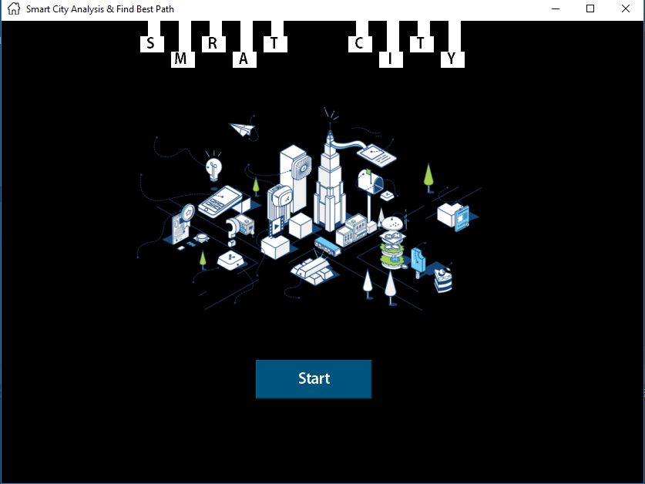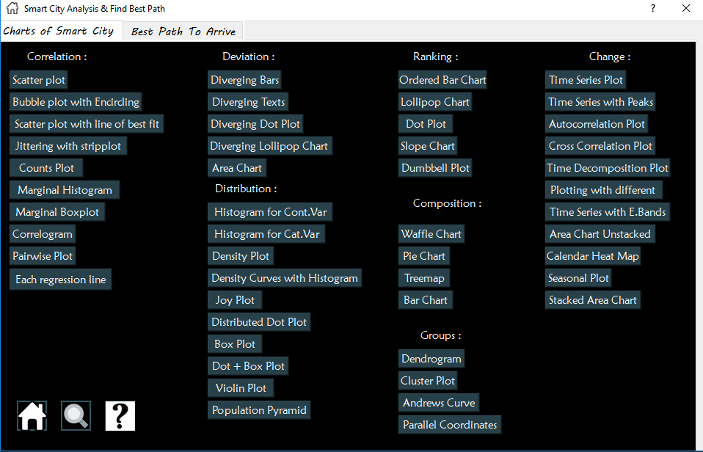
3. In charts click on any button to see its graph.

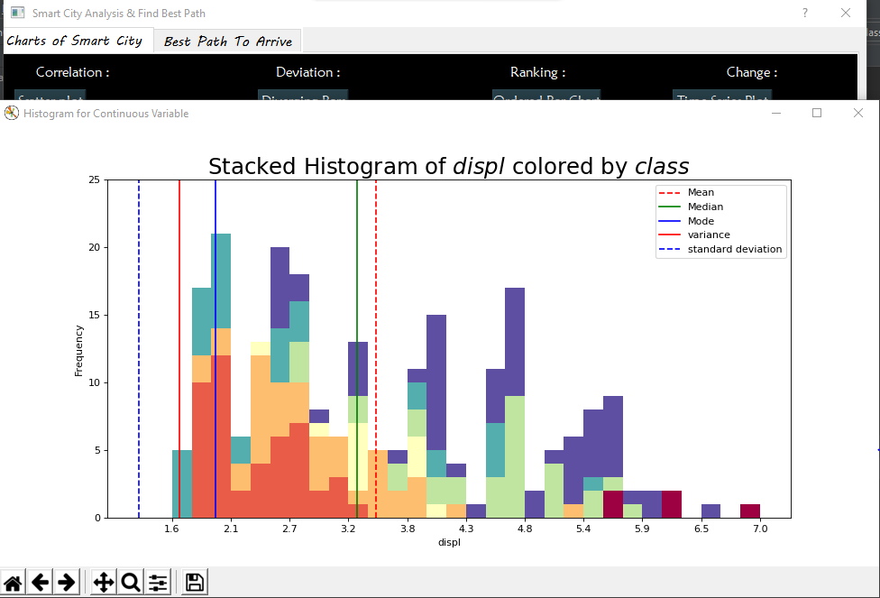

1. In best place to see path with picture and details of path “ you can select any path from 6 paths to see picture of a path and click show way to know this way is empty or heavy and show road in any path and predict what is road will be to 80 days to show that you must select path from 6.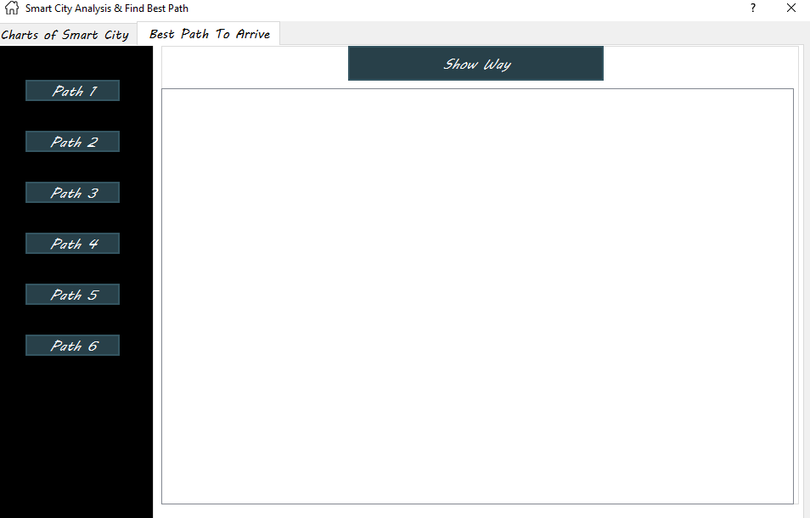

* To Run The Algorithm Only you need to go to project file and open (Find Path Folder). And Write in path ribbon “cmd” .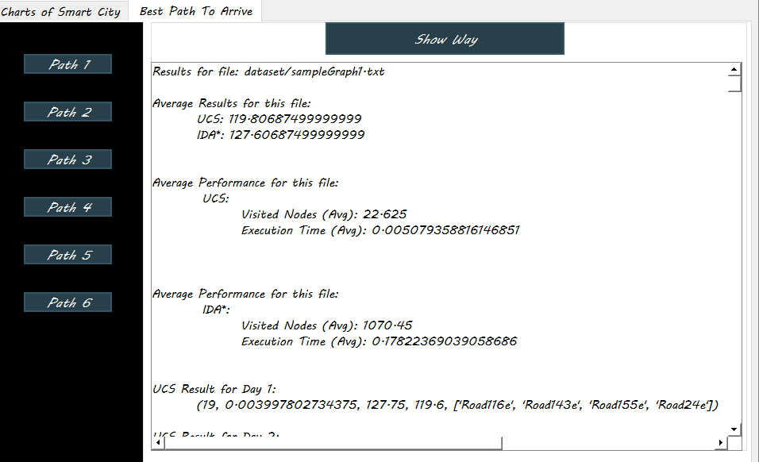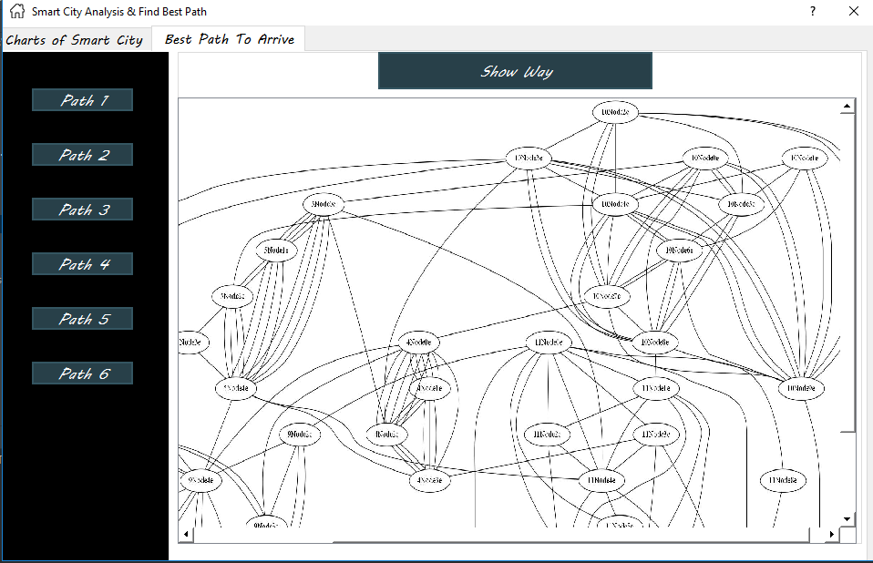
* Then write “python trafficCalculator.py -f “dataset/[The Graph name]”.

# RESULT

Statistical analyzes are frequently used in business for company valuations and in many business decisions, such as stock holding and assessment. Stock volatility is one area where businesses frequently use this analysis to derive results. Businesses also analyze this data during risk management in order to assess the probability of a certain risk being incurred by a company and how substantial the risk may be. Companies also use regression formulas in order to test some of their more general hypotheses about the effect of a certain factor on their assets or market price of stock.

# 

# 

# 

# 

# CONCLUSION

The smart cities concept has gained a lot of attention lately and it will most likely continue to do so in the future. Cities are publishing smart plans; related conferences are trending and more and more books are being written on the subject.

Link on GitHub: <https://github.com/HabibaKhaledMohammed/Smart-City>

# REFERENCES

1. <https://www.sciencedirect.com/science/article/pii/S0264275117308545>
2. <https://github.com/IBM/smart-city-analytics>
3. <https://github.com/DMKM1517/SmartCity?fbclid=IwAR3KxW6UcxUWNTRUADpx9-2CWXI0Ytm1aV6a9banOjCqefyrATKj-GcbXVk>
4. <https://smartcity.readthedocs.io/en/latest/?fbclid=IwAR3qTkSqKCKSO4UqtMuAvDQhpAy6nBLd8EtrrDxgBKmT7QQe2TzvII4rOnY>
5. <https://www.prnewswire.com/news-releases/global-smart-cities---planning-for-a-sustainable-future---analysis-and-trends-300768836.html>
6. <https://instarea.com/smart-city-solution-cesa2017-market-locator/?gclid=Cj0KCQjwh6XmBRDRARIsAKNInDGnUyxsBwb1xkT8eNFsIpOUJxvDmb1R9F2oW5r6RxlbMipnX9wrvTwaAv0JEALw_wcB>